**Exploring the Enchanting Landscapes: A Research Trip in Ladakh 2023**

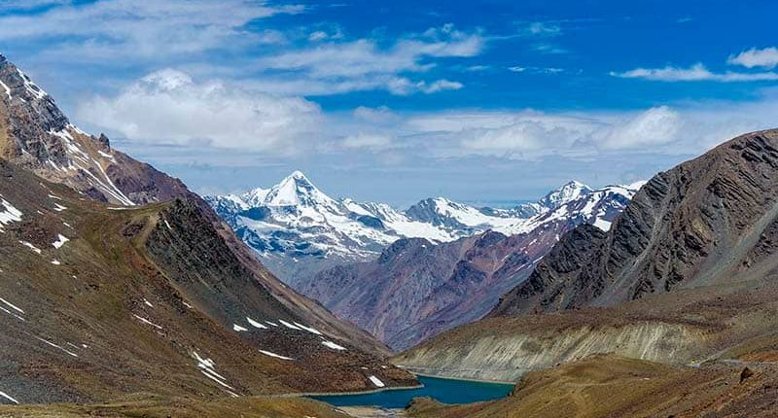

(Source: Tourism of India)

High-altitude deserts, majestic mountains, and a rich cultural tapestry – Ladakh, often called the "Land of High Passes," is a destination that beckons adventurers, researchers, and nature enthusiasts alike. Tucked away in the northernmost region of India, this remote area has captured the imagination of travelers for centuries. Embarking on a research trip to Ladakh is a journey into a world of contrasts, where ancient traditions meet breathtaking landscapes.

**Headed up Leh: 30th May**

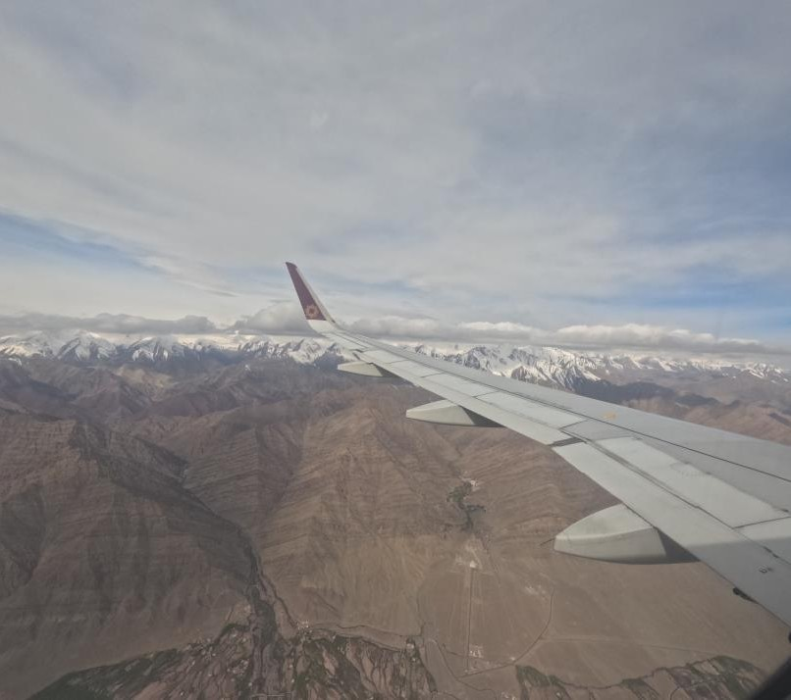

Passing over the Siwalik range and enter into Ladakh

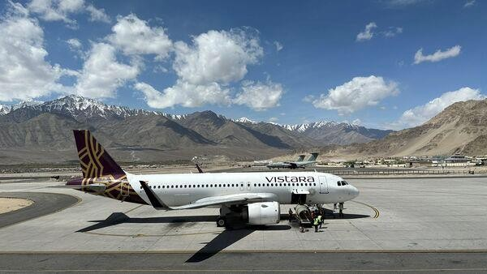

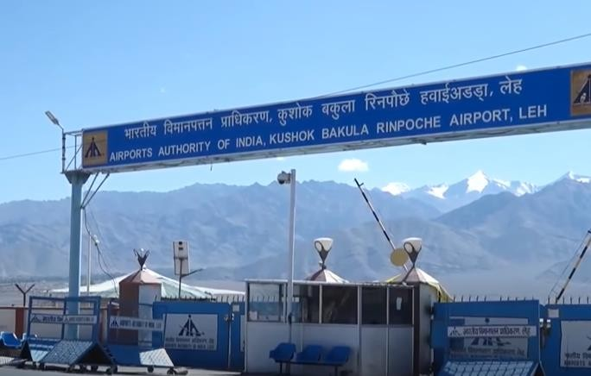

a and b: Airport, Leh (ladakh)

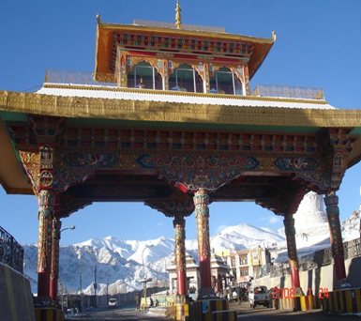

**Day 1: Acclimatisation and Exploring the Markets**

The blue skies and the fresh mountain air around you are just precursors to one of the most remarkable holidays of your life. Use the first day to acclimatize, and avoid anything strenuous. Take your time strolling in and out of the shops in Leh Bazaar.

**Where to shop:**Tibetan Handicraft Community Showroom, Choglamsar (for authentic Ladakhi handmade items), Ladakh Art Palace (for all kinds of handicrafts), Moti Market (for pearl and semi-precious jewelry)

**Places to Eat:**Ladakh Café (Leh’s first vegan café), Bon Appetit

**Lodging details in Leh**

**Name of Hotel/Guest House**: Green Villa Guesthouse   
**Distance from the Airport**: 5.1 km

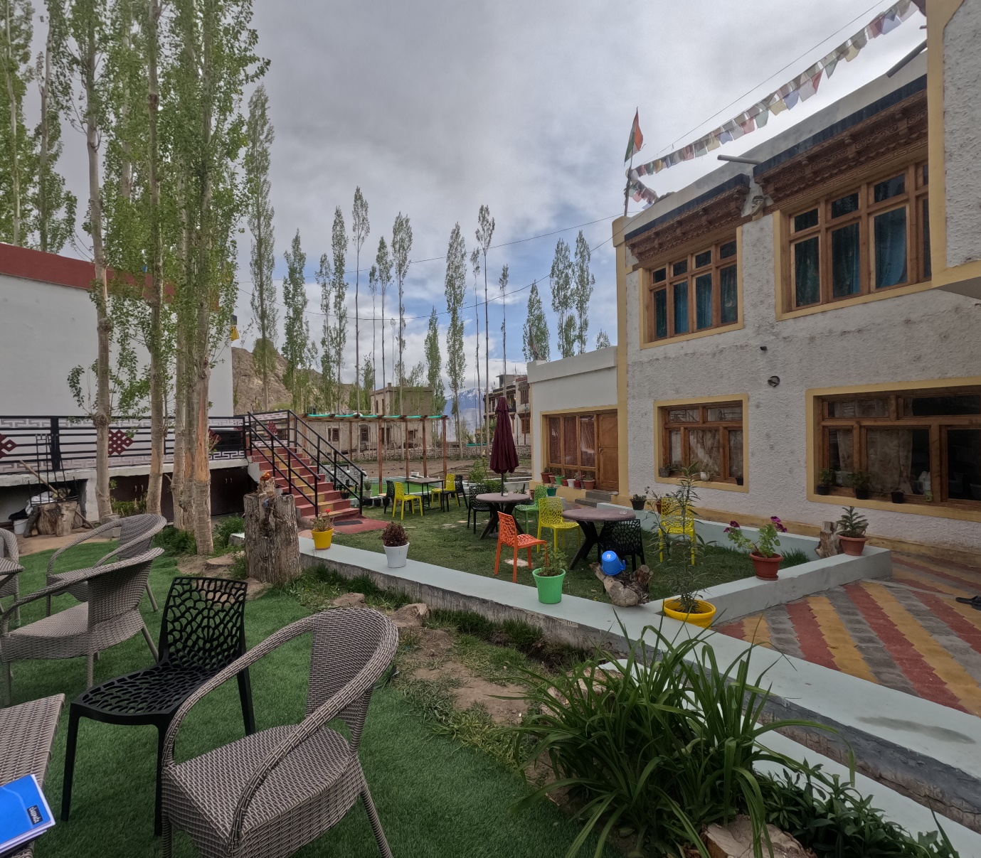

Green Villa Guesthouse

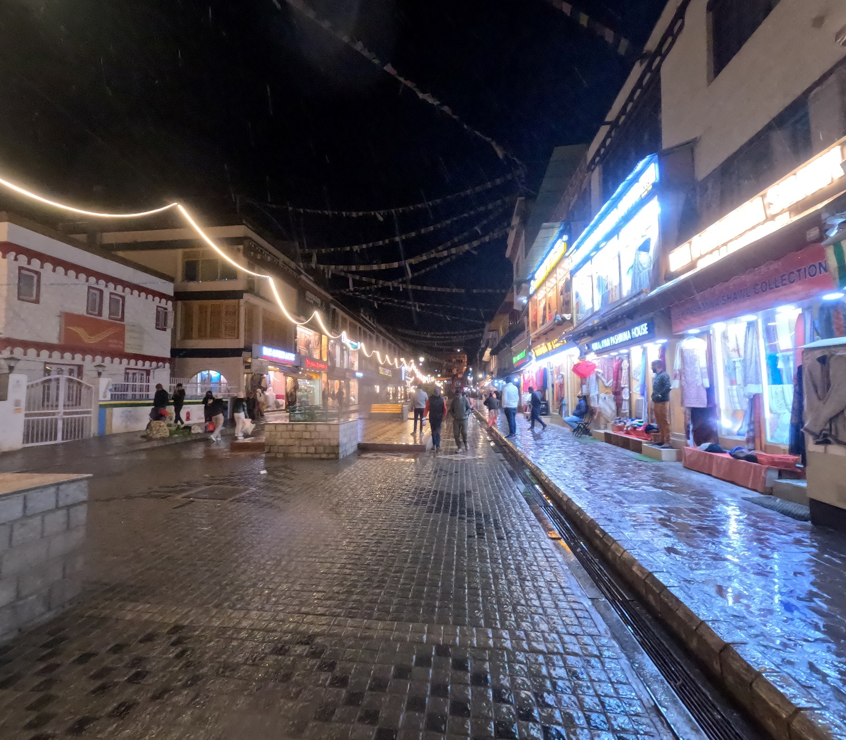

The main market, Leh

**Day 2: Permits and other official works**

An Inner Line Permit or Restricted Area Permit/ Protected Area Permit is an official travel document issued and stamped by the Indian Authorities to allow tourists to visit the protected areas of Ladakh. It is mandatory to obtain a permit for domestic and international tourists visiting the protected areas of Ladakh.

There are two types of permits, namely Inner Liner Permit (ILP) and Protected Area Permit or Restricted Area Permit (PAP/ RAP). These are required to visit those areas which are situated near the international borders, such as in the proximity of the Line of Control (border with Pakistan) and Line of Actual Control (border with China). Due to the security purpose, every tourist requires to obtain them. Here is detailed information about the types of permits, how to obtain them, for which place they are required, and the cost of the permit.

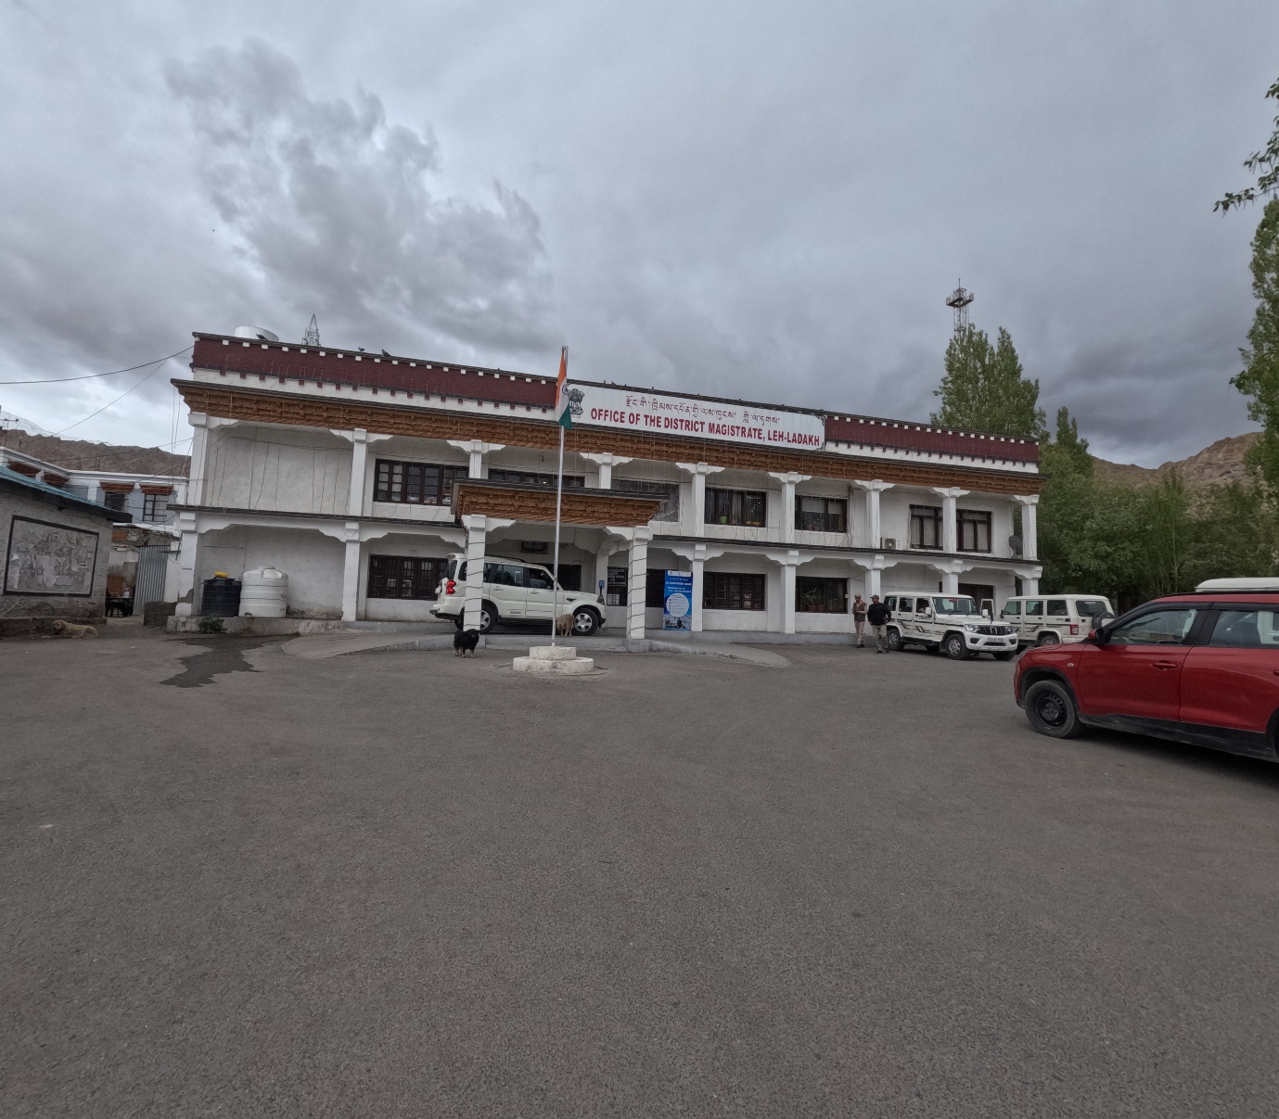

Office of the district-magistrate, Leh (Union territory of Ladakh, India)

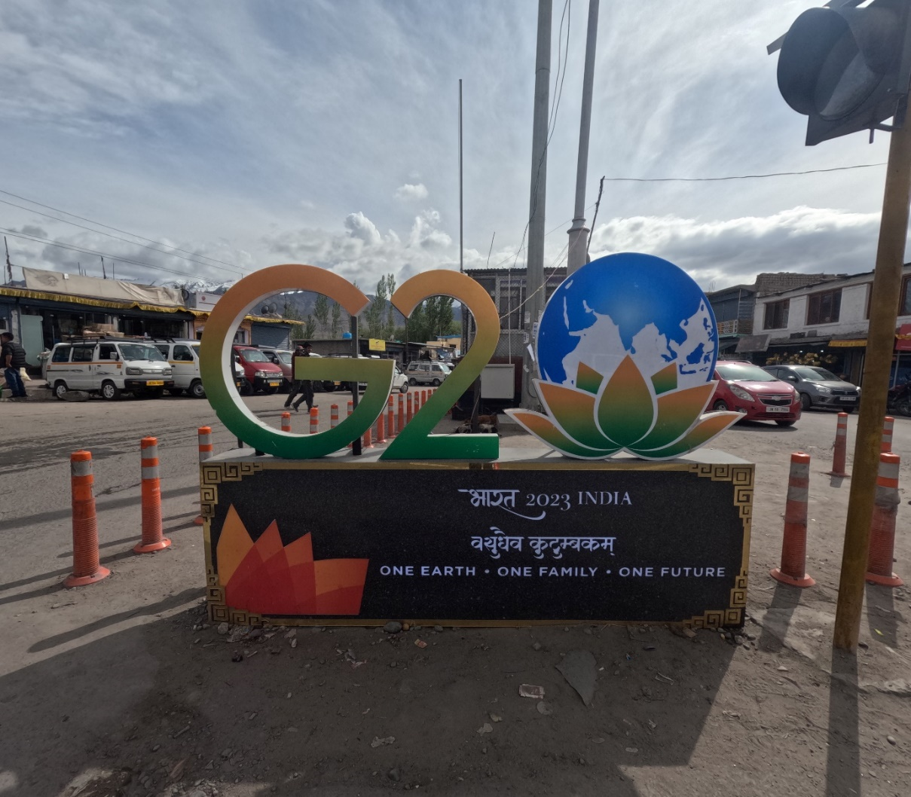

**Unfazed India to hold G-20 event in Leh (Ministry of Youth and Sports Affairs)**

**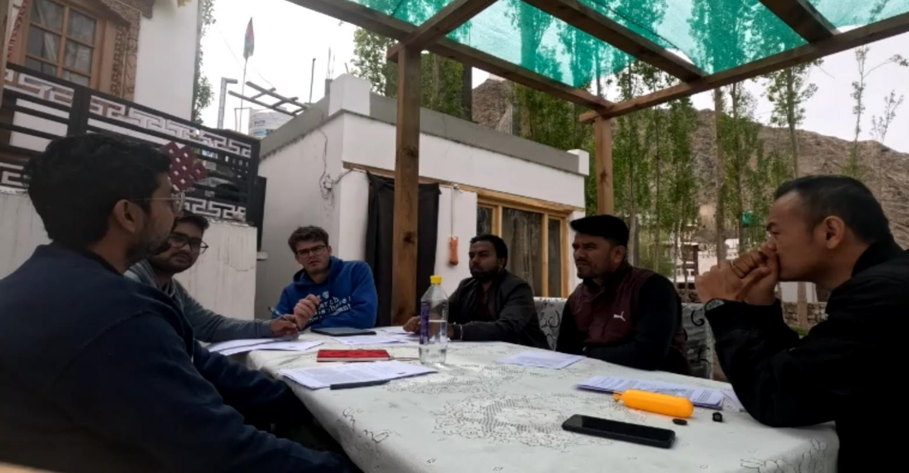  
 Acclimatization with literature review**

**3. Way towards Chumathang:**

**Exploring the Geological Marvels: A Journey Through Time**

Unveiling the Earth's mysteries often requires venturing into the depths of nature's grandeur, and there's no better place to do so than in the rugged landscapes of Ladakh. Nestled in the northernmost region of India, Ladakh is a geological treasure trove that offers a unique opportunity to delve into the intricate history of our planet. A geological field trip to Ladakh is not just an adventure; it's a journey through time itself, where the rocks and landscapes whisper tales of ancient oceans, colliding continents, and the forces that shaped the Earth we know today.

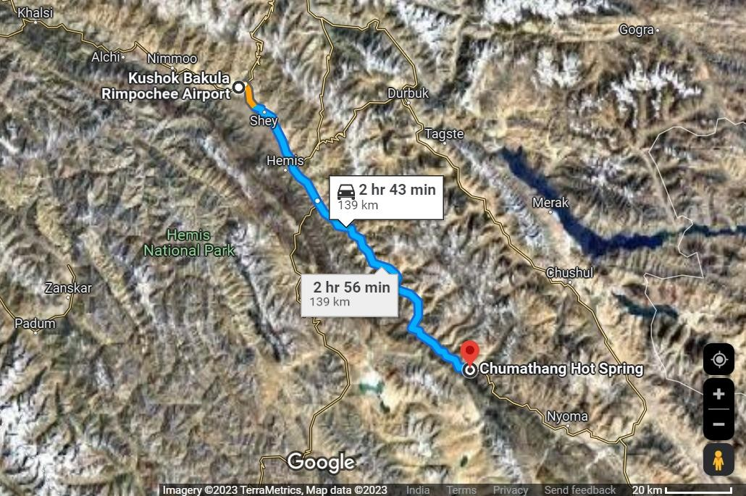

**Chumathang** is a village in [Leh District](https://en.wikipedia.org/wiki/Leh_District), [Ladakh](https://en.wikipedia.org/wiki/Ladakh) in northern [India](https://en.wikipedia.org/wiki/India) on the banks of the [Indus river](https://en.wikipedia.org/wiki/Indus_river). Chumathang village is among the first villages in the Changthang region to have its own power station and government high school which was only possible under the guidance of Mr Gonbo. Famous for its hot spring which attracts many tourists worldwide, even the local people come every year to take the medicinal benefits from the hot spring. There is an old monastery or gonpa which is located near the road which is about more than 400 years old and is among the oldest monasteries of Ladakh.

## Location

Chumathang is 138 km (86 miles) southeast of [Leh](https://en.wikipedia.org/wiki/Leh),  41 km northwest of [Nyoma](https://en.wikipedia.org/wiki/Nyoma),and 29 km (18 miles) from Kiari, where the Indian Army runs a small medical center.

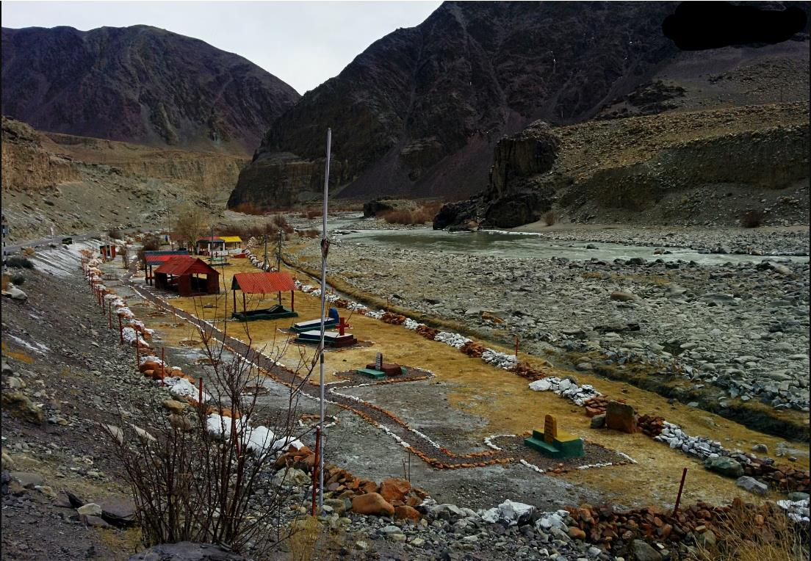

***1962 Indo-China war memorial graves, Leh-Nyoma highway, Changthang***

**Headed up Chumathang: 1st June**

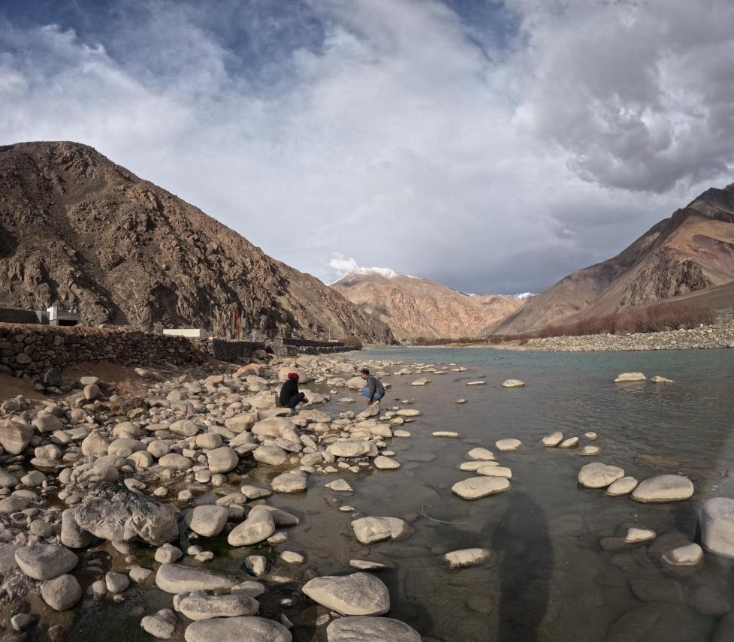

**Try to observe multiple hot springs, Chumathang**

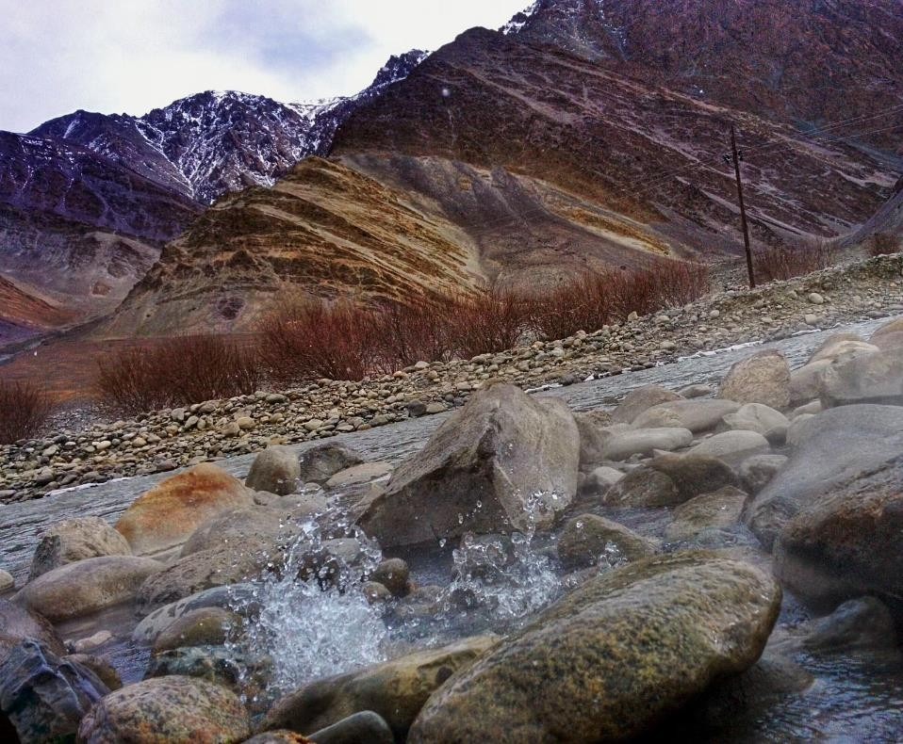

The Canvas of Geological History:

Surface manifestation as Hotspring

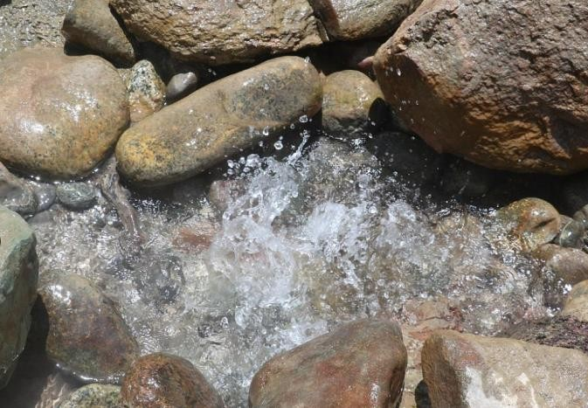

Surface manifestation as Hotspring

Ladakh's landscape is a canvas painted with hues of sedimentary layers, uplifted mountains, and crystalline metamorphic rocks. As geologists and enthusiasts embark on their journey, they find themselves treading upon remnants of a primordial ocean that once covered this region. The unmistakable features of ancient marine life, fossilized coral reefs, and sedimentary rocks tell stories of the distant past when Ladakh was submerged beneath the waves.

The Dance of Tectonic Plates:

One of the most captivating aspects of Ladakh's geology is its connection to the ongoing tectonic drama. The collision of the Indian Plate with the Eurasian Plate has forged the towering peaks of the Himalayas, and Ladakh stands witness to this monumental event. The convergence of these titanic plates has given rise to dramatic geological formations, including thrust faults, fold mountains, and deep valleys. A geological field trip to Ladakh is not merely a journey of sightseeing; it's a journey through the annals of Earth's history. From ancient oceans to tectonic collisions, from fossilized imprints to towering mountains, Ladakh's geology is a testament to the forces that have shaped our planet. As you explore this rugged land, remember that you're not just an observer; you're a participant in the ongoing geological narrative, a witness to the dynamic processes that continue to shape our world.